**TEAM5OIES**

**TEAM5OIES Database Implementation Screenshots**

***Version 2.0***

**Approvals Signature Block**

|  |  |  |  |
| --- | --- | --- | --- |
| **COSC 3380** | **Name** | **Signature** | **Date** |
| SE DBA | John Loveall |  | 04-15-2015 |
| SE DBA | Jessica Balanag |  | 04-15-2015 |
| SE Team Leader | Obinna Ugwuzor |  | 04-15-2015 |
| SE SQA | Shah Zaib |  | 04-15-2015 |
| SE SQA | Edison Guevara |  | 04-15-2015 |

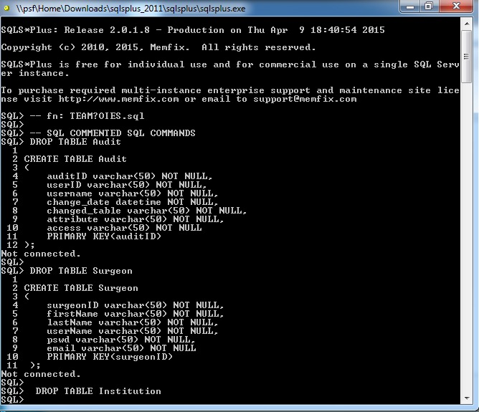

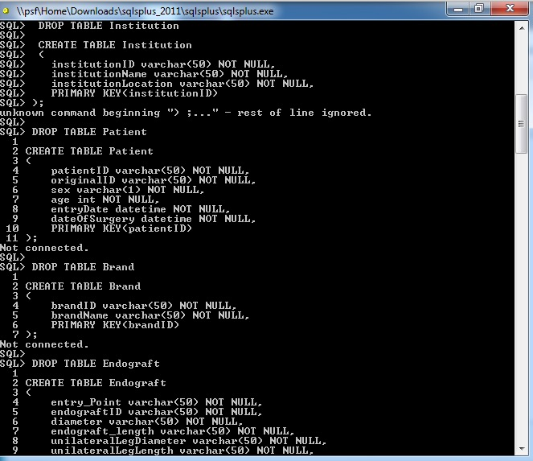

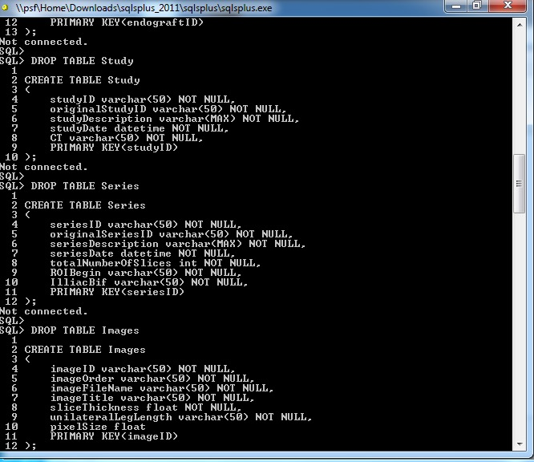

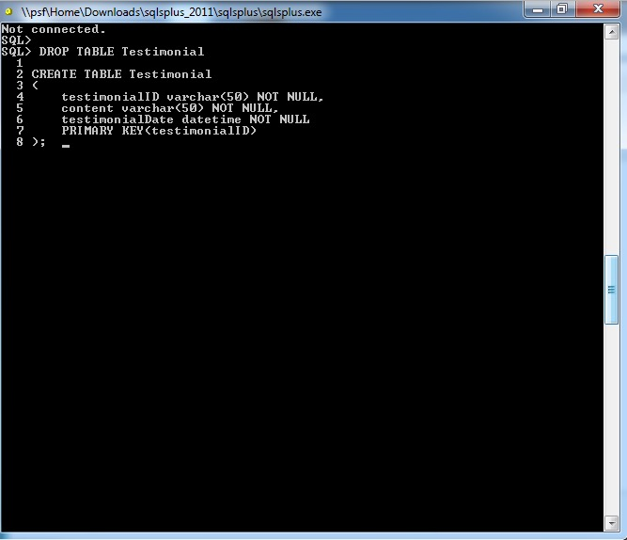

**Document Control**

Change History

**Table 1: TLs entries (assigned work and due dates) before releasing to the team (all SQAs)**

|  |  |  |  |
| --- | --- | --- | --- |
| Revision | Name | Due Date | Description |
| 1.A | DBA Jessica Balanag | 04/10/2015 | Complete database and database queries |
| 1.B | DBA John Loveall | 04/10/2015 | Complete document |
|  |  |  |  |
| 1.X | SQA Shah Zaib | 04/15/2015 | Review Document |
| 1.Y | SQA Edison Guevara | 04/15/2015 | Review Document |

**Table 2: Entries when work completed (SVN Commit Comment matches Description)**

|  |  |  |  |
| --- | --- | --- | --- |
| Revision | Name | **Completed Date** | Description |
| 1.A | DBA Jessica Balanag | 04/10/2015 | I completed database and database queries. |
| 1.B | DBA John Loveall | 04/10/2015 | I completed the functional requirements of the audit table. |
|  |  |  |  |
| 1.N | SQA Edison Guevara | 04/14/2015 | I reviewed Document |

**Table 3: TL entry for RED DELIVERABLES (SVN Commit Comment matches Description)**

|  |  |  |  |
| --- | --- | --- | --- |
| Revision | Name | Due Date | Description |
| 2.0 | TL Obinna Ugwuzor | 04/15/2015 | I changed Version to 2.0 |

Document Storage

This file is stored in SVN at https://svn.cs.uh.edu/svn/cs4351/team**5**/DB TEAM PROJECT DELIVERABLES/ **TEAM5OIES.doc**.